Business Analysis
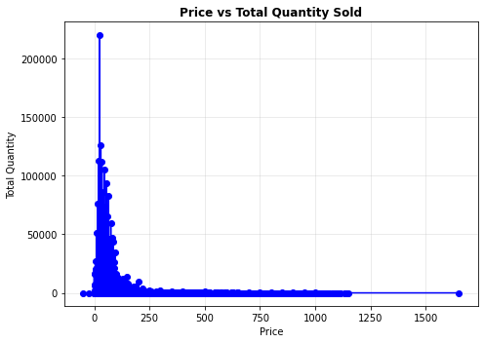

The image illustrates how pricing impacts sales volume, showing a peak at a low price point of x: 25.0 and y: 220222, indicating optimal sales at this price.
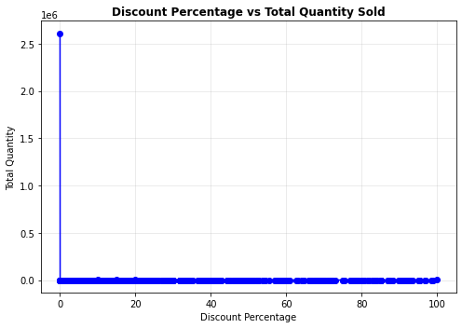
The table indicates that there is no observable correlation between discount percentage and total quantity sold, based on the data.
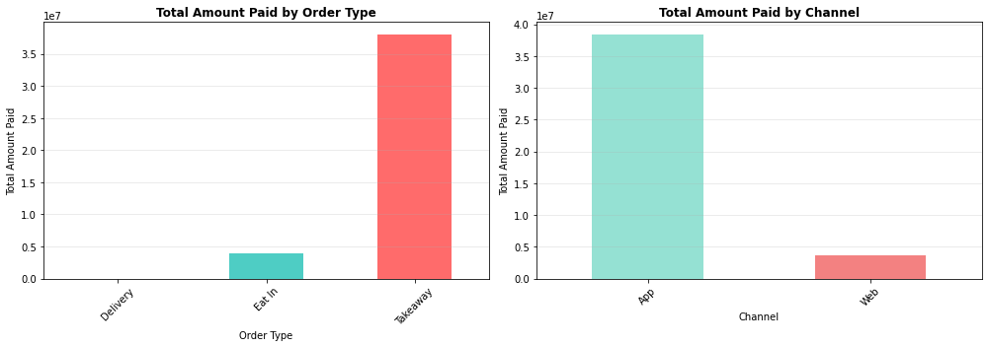
The analysis highlights the total payments by order type and channel, suggesting increased advertising focus on apps and implementing delivery options to enhance service efficiency and customer reach effectively.
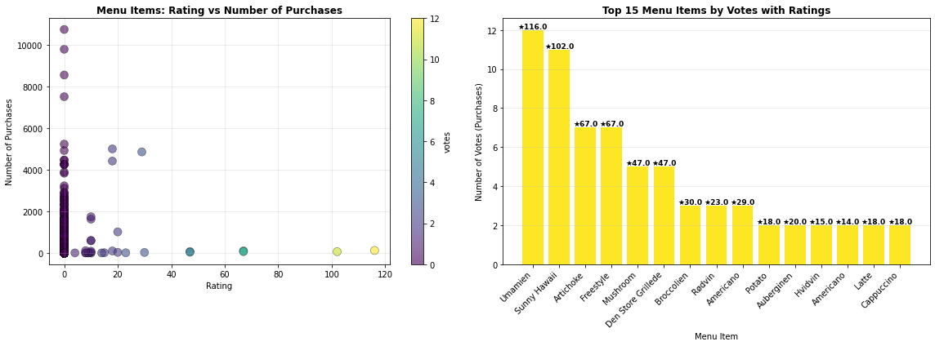
On the right side of the interface, the most highly rated menu items are clearly visible, indicating popular choices based on user feedback. Interestingly, the number of purchases appears to have a negative correlation with ratings; however, the data shows that votes tend to increase alongside higher ratings, suggesting that vote count is not a reliable indicator of popularity. The calculated correlation coefficient between ratings and votes is 0.999, demonstrating a very strong positive relationship. This high correlation confirms that user feedback effectively helps identify quality items, making ratings a valuable metric for assessing menu item popularity and quality.
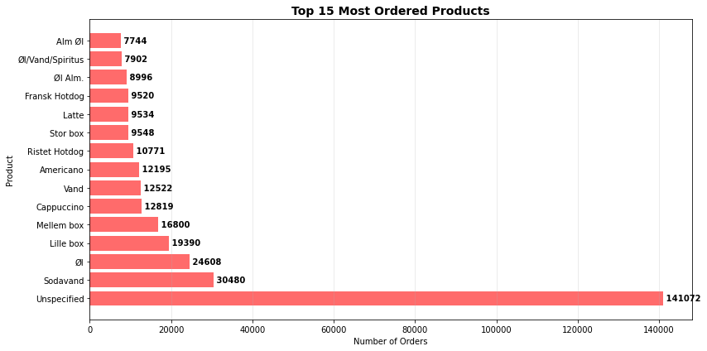
The graph illustrates the top 15 most frequently ordered products, highlighting Sodavand as the most popular item, followed by OI, Little Box, and Mellem Box. These products should be prioritized in marketing efforts to attract more customers. Future campaigns should focus on promoting these key products to maximize sales and customer engagement.
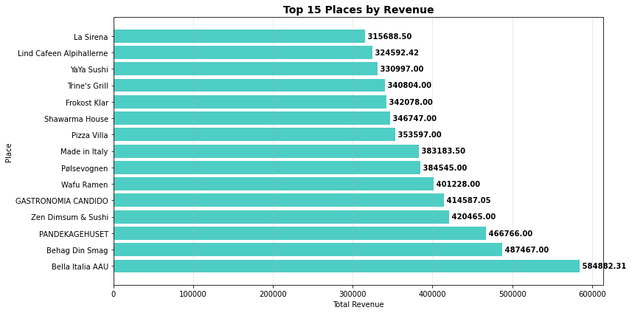
The bar chart highlights the top 15 locations ranked by revenue, with Bella Italia AAU leading as the most profitable. This suggests prioritizing these high-performing venues for targeted campaigns and special offers, maximizing revenue potential. Focusing on these key locations can significantly enhance overall business profitability.
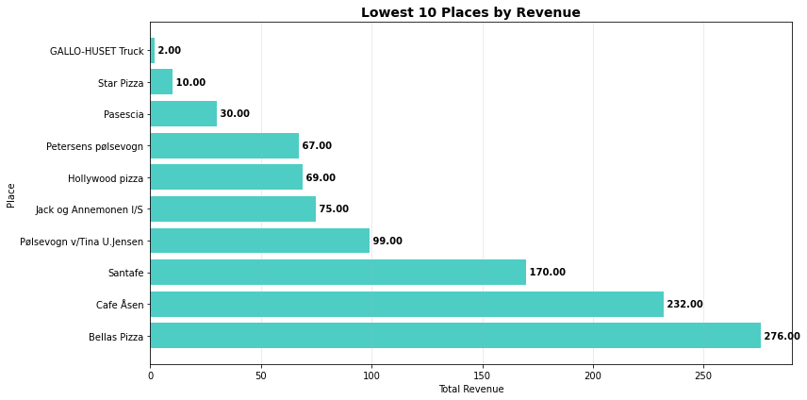
The lowest revenue-generating locations are significantly behind the top performers, indicating a need for strategic shutdowns or improvements to boost overall performance and revenue. These areas require targeted enhancement efforts.
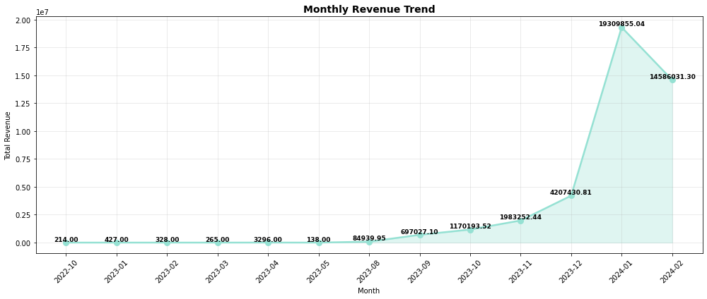
The data indicates a significant revenue increase from 214 in October 2022 to approximately 14,586,031.30 in February 2024, representing a roughly 100,000-fold growth. Notably, an unusual decline occurred between January and February 2024, warranting further investigation into potential causes or anomalies.
….
The average number of orders per user is 4.13. Users falling below this average should receive an email reminder highlighting attractive offers, encouraging them to make additional purchases and increase their engagement with the platform.

